Assignment #1. HTML Basics (Page Structure)

**Name:** Aida Kentay  
**Group:** SE-2428  
**Assignment:** HTML – My First Webpage  
**GitHub Link:** <https://github.com/akentay/Assign-1-Aida.git>

Git Hub page : https://akentay.github.io/Assign-1-Aida/

<!DOCTYPE html>

<html lang="en">

<head>

<meta charset="UTF-8">

<meta name="viewport" content="width=device-width, initial-scale=1.0">

<title>My First Webpage</title>

</head>

<body>

Exp:

<!DOCTYPE html> – tells the browser that this is an HTML5 document.

<html lang="en"> – the root element of the webpage, language set to English.

<head> – contains meta information (not visible on the page).

<meta charset="UTF-8"> – allows the use of all characters, including emojis.

<meta name="viewport" ...> – makes the page responsive for mobile devices.

<title> – sets the name of the webpage tab in the browser.

<body> – the visible content of the webpage starts here.

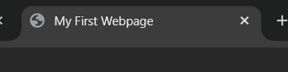

<h1>Aida Kentai</h1>

<h2>Course: Web Technologies</h2>

<h3>About Me</h3>

<p>Hello! My name is Aida. I am a student at Astana IT University.

I am interested in technology, blogging, and media creativity.

This is my first HTML project! </p>

Exp:

<h1>, <h2>, <h3> – headings of different sizes.

<p> – paragraph for text description.

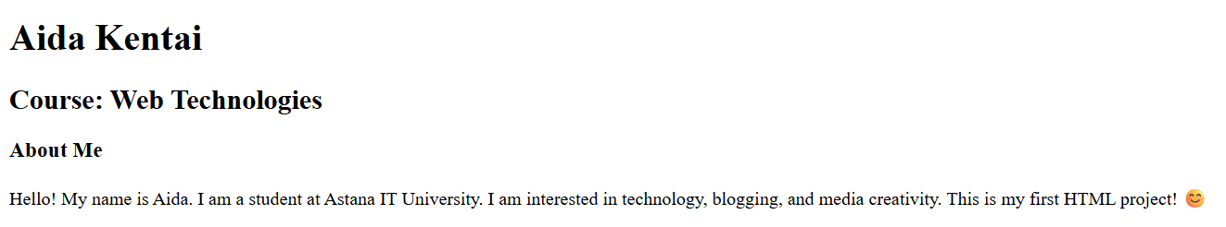

<ol>

<li>Blogging</li>

<li>Watching movies</li>

<li>Traveling</li>

<li>Photography</li>

</ol>

<ul>

<li><a href="https://www.youtube.com" target="_blank">YouTube</a></li>

<li><a href="https://www.tiktok.com" target="_blank">TikTok</a></li>

<li><a href="https://www.instagram.com" target="_blank">Instagram</a></li>

</ul>

Exp:

<ol> – ordered list (with numbers).

<ul> – unordered list (with bullets).

<li> – list item.

<a href="..."> – hyperlink to another website.

target="_blank" – opens link in a new tab.

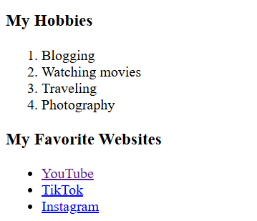

<img src="/mycrush.jpg" alt="My Photo" width="200">

<button>Click Me</button>

Exp:

<img> – displays an image.

src – the file name of the image.

alt – alternative text if the image cannot load.

width="200" – sets the size of the image.

<button> – creates a clickable button (no function yet)

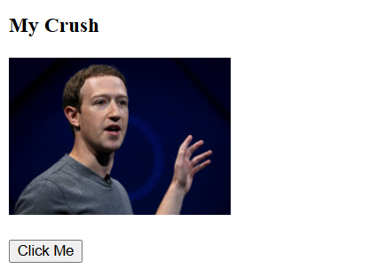

<table border="1" cellpadding="5">

<tr>

<th>Subject</th>

<th>Day</th>

<th>Time</th>

</tr>

<tr>

<td>Web Technologies</td>

<td>Monday</td>

<td>10:00</td>

</tr>

<tr>

<td>Database Systems</td>

<td>Wednesday</td>

<td>12:00</td>

</tr>

<tr>

<td>Calculus</td>

<td>Friday</td>

<td>14:00</td>

</tr>

</table>

Exp:

<table> – creates a table.

<tr> – table row.

<th> – table header (bold).

<td> – table data (cell).

border="1" – draws border lines.

cellpadding="5" – adds spacing inside cells

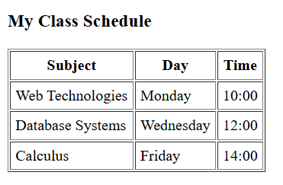

<p>Today I feel great &#128509, a bit tired &#128517, but very motivated &#128513!</p>

Exp: Emojis are added using **HTML entities (&#number;)**.

Example: &#128513; = 😁

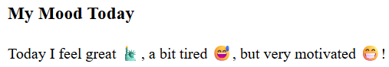

<form>

<label for="name">Name:</label>

<input type="text" id="name" name="name"><br><br>

<label for="email">Email:</label>

<input type="email" id="email" name="email"><br><br>

<label for="color">Favorite Color:</label>

<input type="color" id="color" name="color"><br><br>

<input type="submit" value="Submit">

</form>

Exp:

<form> – creates a form.

<label> – description for input fields.

<input type="text"> – text input.

<input type="email"> – email input (validates email format).

<input type="color"> – color picker.

<input type="submit"> – submit button

Изображение выглядит как текст, снимок экрана, Шрифт, диаграмма

Содержимое, созданное искусственным интеллектом, может быть неверным.